## Security

The system is not secure in all areas. It requires a username and password in order for a user to login. It does not allow users without the necessary authorisation to delete buzz spaces, but anyone can create a buzz space. Only authorised users can add or remove admins. The system is also somewhat configurable, MIME types can be added, edited, and removed, but the system does not take authorisation level into account for these actions, anyone can perform these actions.

Log in

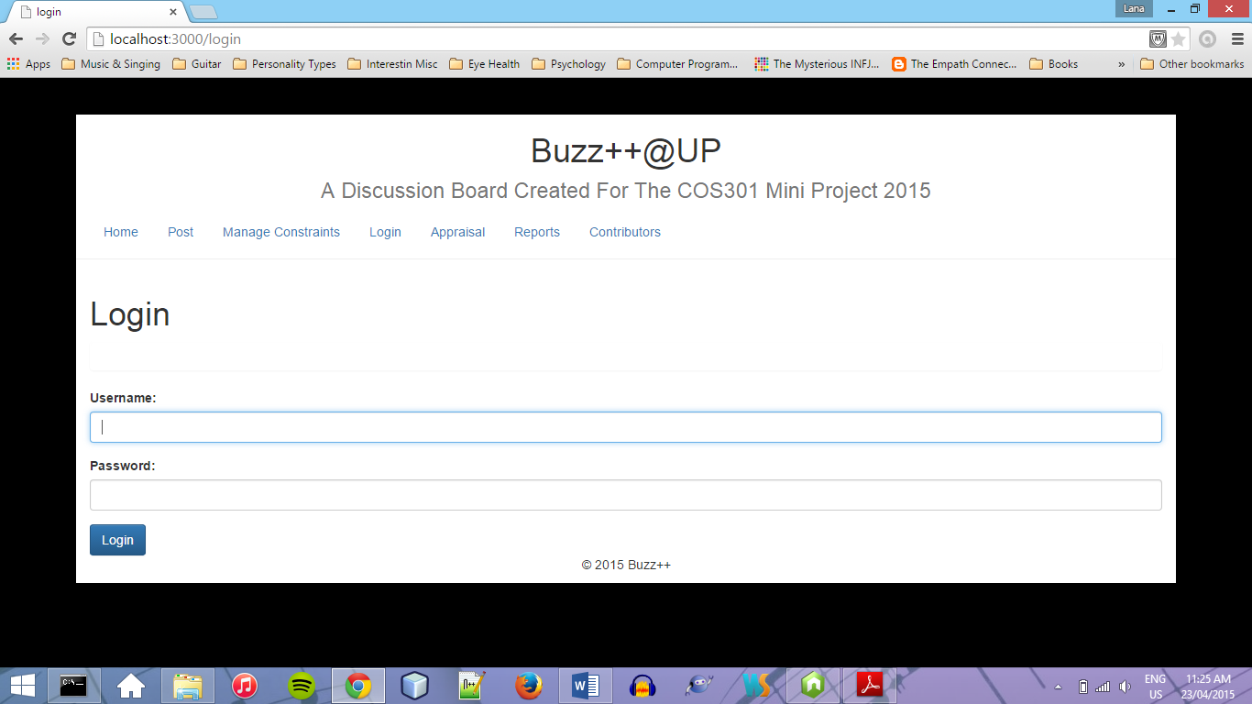

Determine if the user is authorised to close the buzz space:

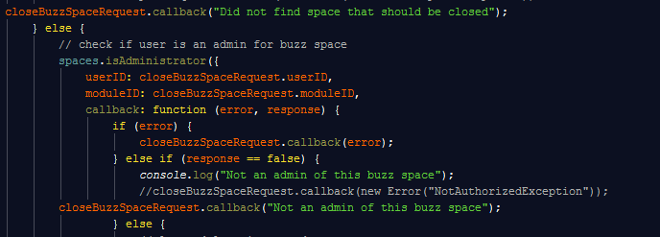

Assign an admin to a BuzzSpace:

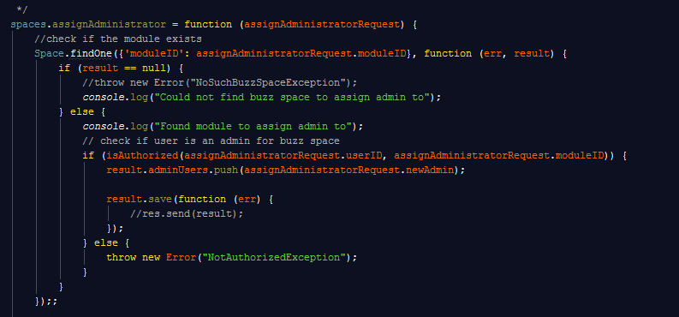

## Auditability

The system does not support auditability. There is no log file or means of keeping record of the requests and who made them, and the responses to these requests.

## Testability

It is possible to test the system t